A table is a collection of related data, and it consists of columns and rows. Databases are useful when storing information categorically.

**3.2.2 Html (Hypertextmarkup Language)**

HTMLstands for Hypertext Markup language, and it is the language in which, until recently, virtually all Web pages were written. HTML is not a programming language, it is a markup language. A markup language is a set of markup tags HTML and it uses markup tangs to describe web pages.

Hypertext refers to the way in which Web pages (HTML documents) are linked together. When you click a link in a Web page, you are using hypertext. It is this system of linking documents that has made the World Wide Web the global phenomenon it has become.

Markup Language describes how HTML works. With a markup language, you simply “mark up” a text document with tags that tell a Web browser how to structure it. HTML originally was developed with the intent of defining the structure of documents (headings, paragraphs, lists, and so forth) to facilitate the sharing of scientific information between researches. All you need to do to use HTML is to learn what type of markup to use to get the results you want.

**3.2.3 Jsp**

The JSP is a text-based document that describes how to process a request to create a response. Java server pages technology enable you to mix regular, static HTML with dynamically web-page-building tools. You then enclose the code for dynamic parts in special tags, most of which starts with<% symbol and end with %>.

**3.2.4 Tomcat Server**

Tomcat is an open source web server developed by Apache Group. Apache Tomcat is the servlet container that is used in the official Reference Implementation for the Java Servlet and Java Server pages technologies. The Java Servlet and Java Server pages specifications are developed by Sun under the Java Community Process. Web Servers like apache tomcat support only web components (BEAs WebLogic, is one of the popular application server).To develop a web application with jsp/servlet install any web server like JRun, Tomcat etc. to run your application.

**3.3 SQL COMMANDS AND QUERIES**

* + 1. **Create Table statements**
* create table AdminDb(Adminid varchar(20) primary key,Adname varchar(20), passward varchar(20));
* create table AddnewAcunt(AcuntNoint NOT NULL Auto_increment primary key, Fname varchar(20),Lname varchar(20),Passward varchar(20));
* create table UserData(AcuntNoint NOT NULL,Fname varchar(20) NOT NULL,Lname varchar(20) NOT NULL,Address varchar(20) NOT NULL,MobileNo varchar(20),cattleType varchar(20),action varchar(20) DEFAULT NULL,foreign key(AcuntNo) references AddnewAcunt(AcuntNo) on delete cascade);
* create table Fatset(Fatrange varchar(20),Price int,Time varchar(20));
* create table SessionData(AcuntNoint NOT NULL,Date DATETIME NOT NULL DEFAULT CURRENT_TIMESTAMP,Time varchar(20) NOT NULL,Litresint NOT NULL, Fat int NOT NULL,TotalPrize varchar(20) NOT NULL,Remarks varchar(50) NOT NULL, foreign key(AcuntNo) references AddnewAcunt(AcuntNo) on delete cascade);

**3.3.2 Stored Procedure Creation**

DELIMITER $$

CREATE PROCEDURE FUNC(IN addre VARCHAR(20),IN mobile VARCHAR(20),IN cattle VARCHAR(20),IN AcuntNb INT)

BEGIN

IF addre<>'' THEN

update userdataset Address=addrewhere AcuntNo=AcuntNb;

END IF;

IF mobile <> '' THEN

updateuserdata set MobileNo=mobile where AcuntNo=AcuntNb;

END IF;

IF cattle <> '' THEN

update userdatasetcattleType=cattle whereAcuntNo=AcuntNb;

END IF;

END

DELIMITER $$

CREATE PROCEDURE Userdata(IN AcuntN INT,IN Fat VARCHAR(20),IN Time VARCHAR(20),IN Litres INT,IN Remarks VARCHAR(20))

BEGIN

DECLARE TotalPrize INT;

SET @prz := (SELECT Prize from fatset where Fatrange=Fat);

SELECT @prz;

SET TotalPrize = Litres * @prz;

Insert into SessionData (AcuntNo,Time,Litres,Fat,TotalPrize,Remarks)

Values(AcuntN,Time,Litres,Fat,Totalprize,Remarks);

END

**3.3.3 Trigger Creation**

CREATE TRIGGER AFTER_AddnewAcunt_insert

AFTER insert ON AddnewAcunt

FOR EACH ROW

BEGIN

INSERT INTO UserData

SET action ='insert',

AcuntNo=NEW.AcuntNo,

Fname=NEW.Fname,

Lname=NEW.Lname;

END$$

3.3.4 **Queries**

String sql = "select AcuntNo from userData where Fname=('"+update+"')";

String sql = "delete from Addnewacunt where AcuntNo="+AcuntNbr+"";

stm.executeUpdate("update userData set Address='"+Address+"',MobileNo='"+MobileNo+"',cattleType='"+CattleType+"' where AcuntNo='"+AcuntNb+"'");

stm.executeUpdate("call userdata('"+addre+"','"+mobile+"','"+cattle+"','"+AcuntNb+"')");

String sql = "select *from userData where AcuntNo=('"+AcuntNbr+"')";

String sql1 = "select sum(Litres) as A,sum(TotalPrize) as B,avg(Fat) as C,SUM(CASE WHEN Time = 'Morning' THEN 1 ELSE 0 END) AS Morning, SUM(CASE WHEN Time = 'Evening' THEN 1 ELSE 0 END) AS Evening,SUM(CASE WHEN Remarks = 'Hygiene' THEN 1 ELSE 0 END) AS Hygiene, SUM(CASE WHEN Remarks = 'NotHygiene' THEN 1 ELSE 0 END) AS NotHygiene from sessiondata where AcuntNo='"+AcuntNbr+"' and Date>='"+Date+"'";

* 1. **OUTPUT TESTING**

While executing Jsp MySQL connection code we were not able to make the connection of backend MySQL to middle tier Jsp. So to solve this problem we had to create a new MySQL user with password. After this the connection was successful.

The connection was successful but the data entered in front end was not stored in backend, since all the attributes data type in backend was not set to varchar. So we modified the Jsp code and MySQL query accordingly.

The attributes are stored in backed successfully but the data stored in backend was not displaying in frontend while calling the stored data to frontend, since all the attributes data type in backend was not same as frontend. So we modified the Jsp code and MySQL query accordingly.

Could not find a stored procedure unhandled execution occurs during the execution of the web request.

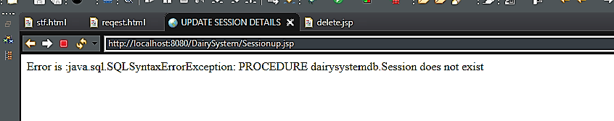

**Fig 3.1:Unhandled exception**

Figure 3.1 shows unhandled exception occurred during execution of the sessionup page this may occur because the specified stored procedure not present in the database.

Could not find a stored procedure unhandled execution occurs during the execution of the web request.

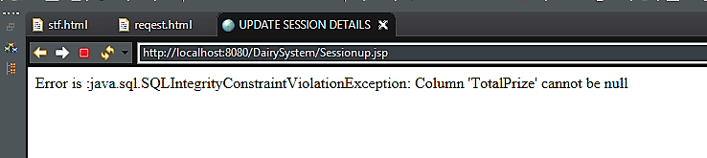

**Fig 3.2: SQL Exception**

Figure 3.2 shows SQL Exception occur during runtime because the specified value in presentation tier Cause IntegrityConstraintViolationExceptionin the Data base.